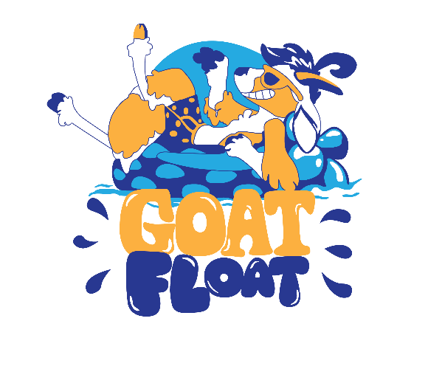
PHEF Goat Float FAQ
What do you mean by “Virtual”
In light of 6’ distancing, mask requirements and the many unknowns around Covid-19, we made the decision to host an event that you can do on your own timeline, where you want & with who you feel comfortable. Do it when it works best for you and your “goat” crew!
Do I have to float that week only?
Nope, feel free to float any time that works for you. Just be sure to post your pictures the week of August 31st to be entered in the competition for prizes.
What do you mean by body of water? Does that include a pool?
Absolutely! As long as you deem it a body of water, so do we. Feel free to float a river, lake, ocean, stream, or pool!
How about a bathtub?
Sure, just remember this is a family friendly event, make sure your photos are appropriate for social media. Inappropriate photos will be removed & disqualified from the event.
Are there prizes?
You know it, PHEF will be rewarding people based upon Billie Pride, most creative vessel, best kid float, as well as a drawing from all entries. Check back soon for the entire list.
Wondering what the prizes are?
Gift certificates to local businesses who have supported us, Goat floats, & other fun stuff.
What do I get with my registration fee?
You get the opportunity to support the student & teacher at PHSD, an official Goat Float “X” along with the chance to get bragging rights for your creative float!
Can I fundraise above and beyond the entry fee?
We would LOVE it if you did. The top fundraiser will win a 30 can Chinook soft sided cooler filled with towels, sunscreen, beverages/snacks & an REI gift card. So get asking!
Can we do it as a group?
Yes, just note that each category will be awarded one prize.
Can we sponsor the event?
Yes, check out PHEF website for more details.

